|  |  |  |  |  |  |  |  |  |  |  |
| --- | --- | --- | --- | --- | --- | --- | --- | --- | --- | --- |
| Instruction | Regdst | ALUSrc | MemtoReg | RegWrite | MemRead | MemWrite | Branch | AluOp2 | AluOp1 | AluOp0 |
| R-format | 1 | 0 | 0 | 1 | 0 | 0 | 0 | 0 | 1 | 0 |
| lw | 0 | 1 | 1 | 1 | 1 | 0 | 0 | 0 | 0 | 0 |
| sw | **1** | 1 | **0** | 0 | 0 | 1 | 0 | 0 | 0 | 0 |
| beq | **1** | 0 | **0** | 0 | 0 | 0 | 1 | 0 | 0 | 1 |
| lui | 0 | 1 | 0 | 1 | 0 | 0 | 0 | 0 | 1 | 1 |
| addi | 0 | 1 | 0 | 1 | 0 | 0 | 0 | 0 | 0 | 0 |
| andi | 0 | 1 | 0 | 1 | 0 | 0 | 0 | 1 | 0 | 0 |
| ori | 0 | 1 | 0 | 1 | 0 | 0 | 0 | 1 | 0 | 1 |

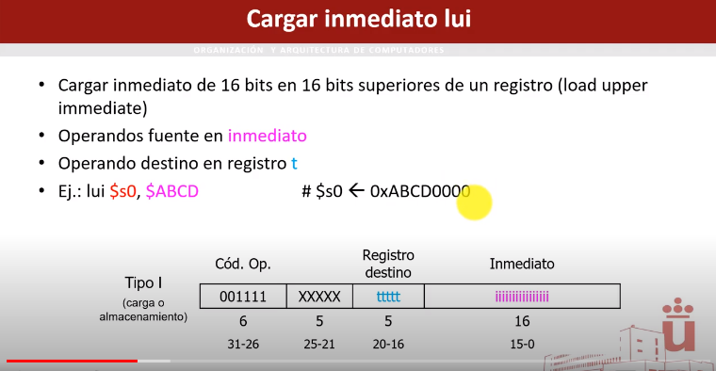

|  |  |  |  |  |  |  |  |  |  |  |
| --- | --- | --- | --- | --- | --- | --- | --- | --- | --- | --- |
| Instruction | Regdst | ALUSrc | MemtoReg | RegWrite | MemRead | MemWrite | Branch | AluOp2 | AluOp1 | AluOp0 |
| R-format | 1 | 0 | 0 | 1 | 0 | 0 | 0 | 0 | 1 | 0 |
| lw | 0 | 1 | 1 | 1 | 1 | 0 | 0 | 0 | 0 | 0 |
| sw | **1** | 1 | **0** | 0 | 0 | 1 | 0 | 0 | 0 | 0 |
| beq | **1** | 0 | **0** | 0 | 0 | 0 | 1 | 0 | 0 | 1 |
| lui | 0 | 1 | 0 | 1 | 0 | 0 | 0 | 0 | 1 | 1 |
| addi | 0 | 1 | 0 | 1 | 0 | 0 | 0 | 0 | 0 | 0 |
| andi | 0 | 1 | 0 | 1 | 0 | 0 | 0 | 1 | 0 | 0 |
| ori | 0 | 1 | 0 | 1 | 0 | 0 | 0 | 1 | 0 | 1 |